LAB 3 : Data Preparation

1. Introduction & Methodology

The objective of this project is to predict the severity of traffic accidents (`crash_type`) using a dataset of traffic records. To maximize model performance, we implemented a "tournament" optimization strategy. Instead of applying a fixed sequence of transformations, we treated each preprocessing step as a competition between two distinct strategies. At each stage, the strategy that yielded the highest improvement in F1-Score (averaged over KNN and Naive Bayes) was retained for the next step.

2. Phase I: Domain-Driven Feature Engineering

Before entering the automated pipeline, we applied manual feature engineering to reduce dimensionality and capture complex relationships.

Cardinality Reduction:
Action: High-cardinality variables like `prim_contributory_cause` (40+ categories) and `traffic_control_device` (19 categories) were grouped into broader semantic buckets (e.g., Driver Error, Distracted, External Factor).
Justification: Extreme cardinality leads to sparse matrices after One-Hot Encoding (Curse of Dimensionality), causing overfitting and slow training.

Cyclical Encoding:
Action: Temporal variables (`crash_hour`, `month`) were transformed using Sine/Cosine functions.
Justification: This preserves the temporal continuity (e.g., 23:00 is close to 00:00), which standard numerical encoding fails to capture.
Interaction Features:

3. Phase II: Pipeline Optimization Tournament

Step 1: Missing Value Imputation (MVI) & Encoding
We did MVI and encoding at the same step because the dataset didn’t have Nan values but ‘UNKNOWN’. Thus, if we encode before we lose information on missing values.
Strategies Evaluated:
1. Statistical Imputation: Filling missing values with the Mean (numerical) or Mode (categorical).
2. Constant Imputation: Filling with a fixed value (-1).
Justification: Statistical imputation preserves the original data distribution, whereas Constant imputation treats "missingness" as a signal in itself (e.g., a missing value might imply a specific type of hit-and-run or recording error).
Verdict: The statistical imputation proved superior.
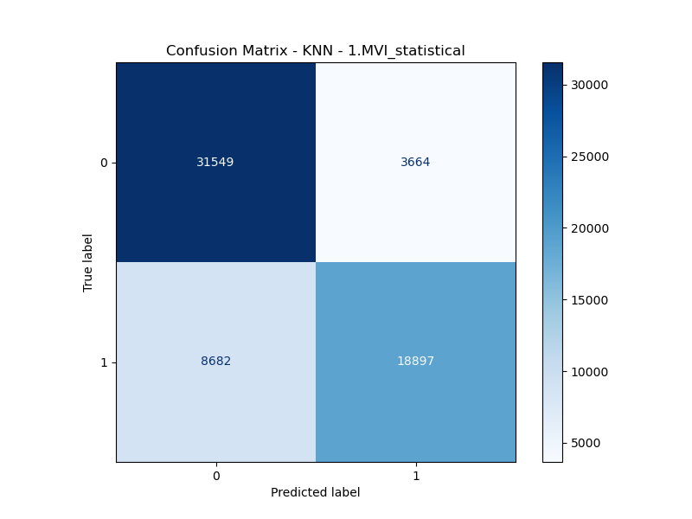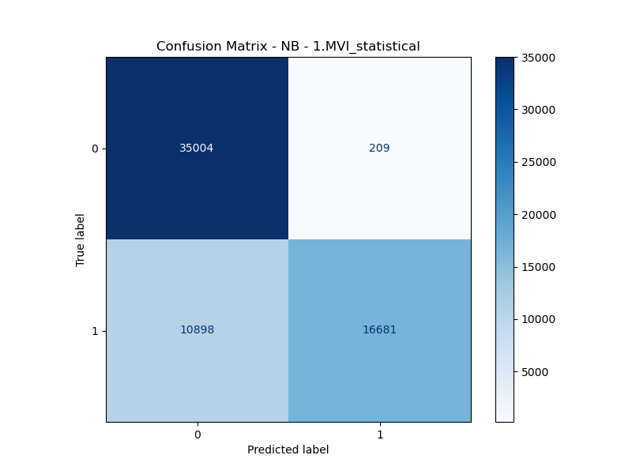

Step 2: Outlier Handling
Strategies Evaluated:
1. Truncate (Capping): Limiting extreme values to a specific percentile (e.g., 99th).
2. Replace: Replacing outliers entirely with the median/mean.
Justification: Traffic data contains legitimate extreme events (e.g., a pile-up involving 10 cars). Truncating preserves the "extremeness" without allowing it to skew distance calculations, while Replacing removes the anomaly entirely to focus on "typical" crashes.
Verdict: The truncate approach was selected.
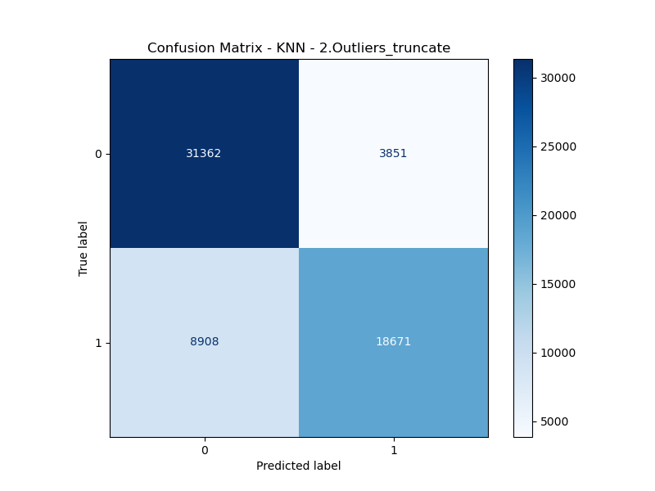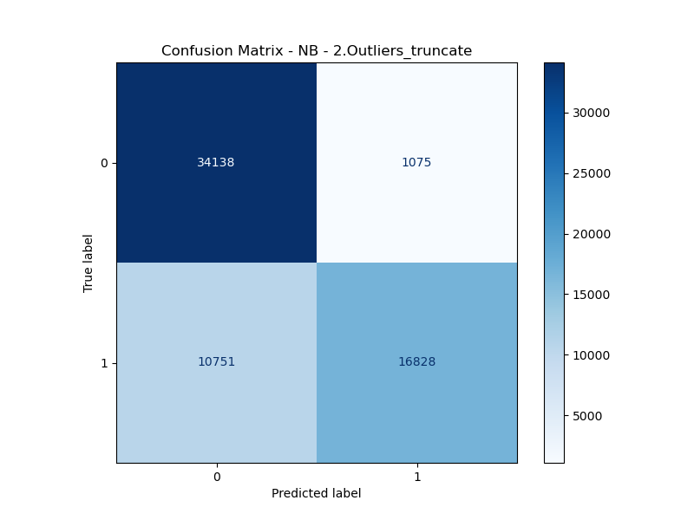

Step 3: Feature Scaling
Strategies Evaluated:
1. Standardization (Z-Score): Centers data around 0 with a standard deviation of 1.
2. Normalization (Min-Max): Scales data between 0 and 1.
Justification: Distance-based algorithms like KNN are highly sensitive to the scale of data. Standardization is generally more robust to outliers, while Normalization preserves the exact relationships within a bounded range.
Verdict: The Standardization strategy won.
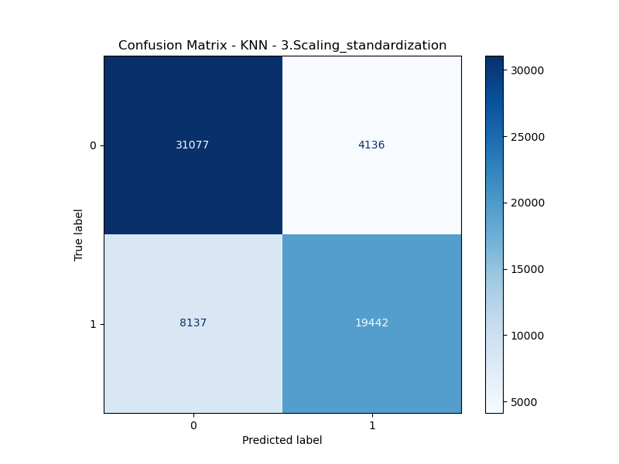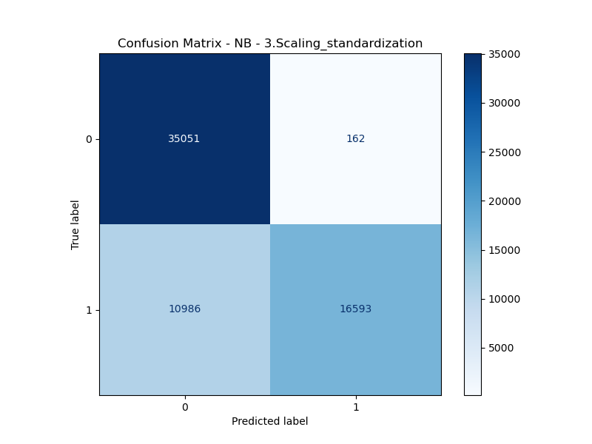

Step 4: Class Balancing
Strategies Evaluated:
1. SMOTE (Synthetic Minority Over-sampling Technique): Generates synthetic examples of the minority class.
2. Random Oversampling: Duplicates existing minority class records.
Justification: The dataset is imbalanced (fewer severe crashes than minor ones). SMOTE helps the model generalize by creating plausible new examples, while Oversampling reinforces decision boundaries around existing examples.
Verdict: The SMOTE strategy yielded the best results.

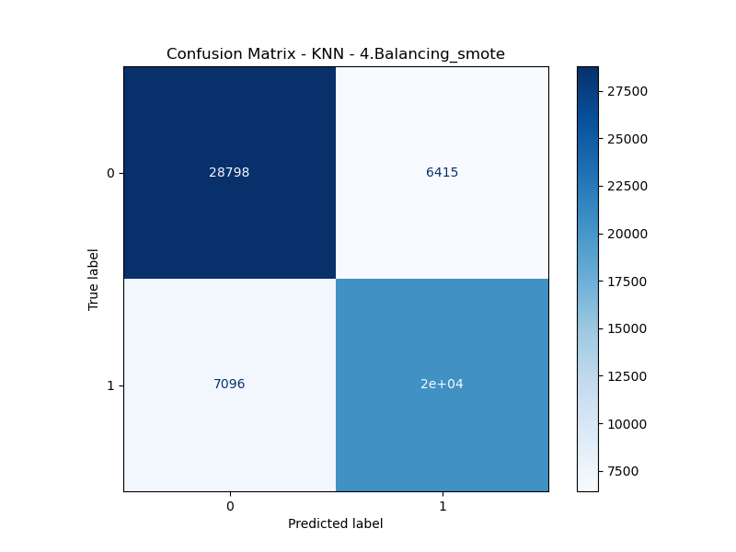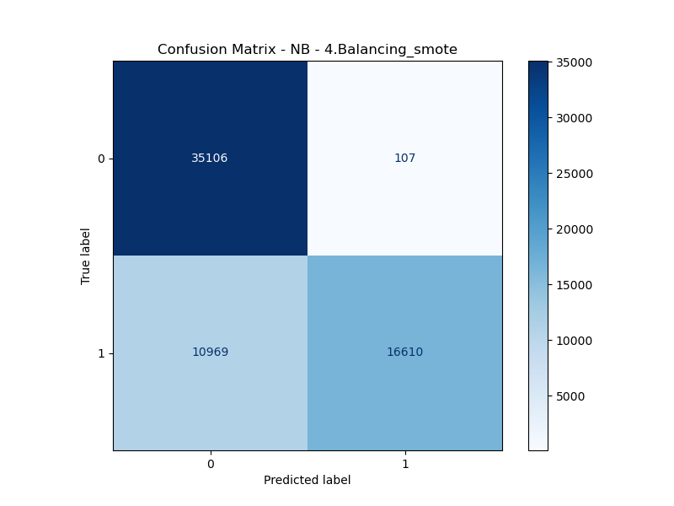

Step 5: Feature Selection
Strategies Evaluated:
1. SelectKBest: Selects the top K features based on statistical tests (Chi2/ANOVA).
2. Correlation Threshold: Removes features that are highly correlated with each other to reduce redundancy.
Justification: Removing irrelevant or redundant features reduces noise and model complexity (Occam's Razor). KBest focuses on relevance to the target, while Correlation focuses on reducing multicollinearity.
Verdict: The kbest was superior.
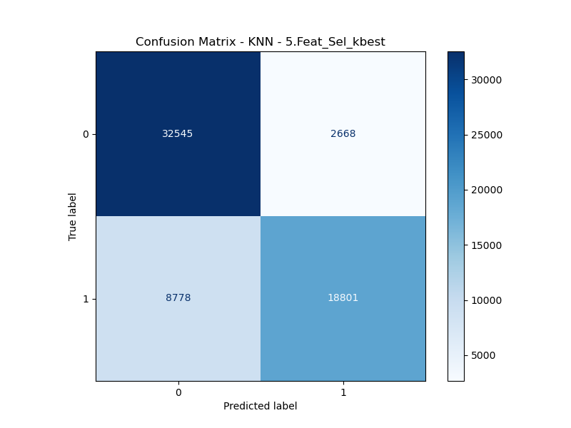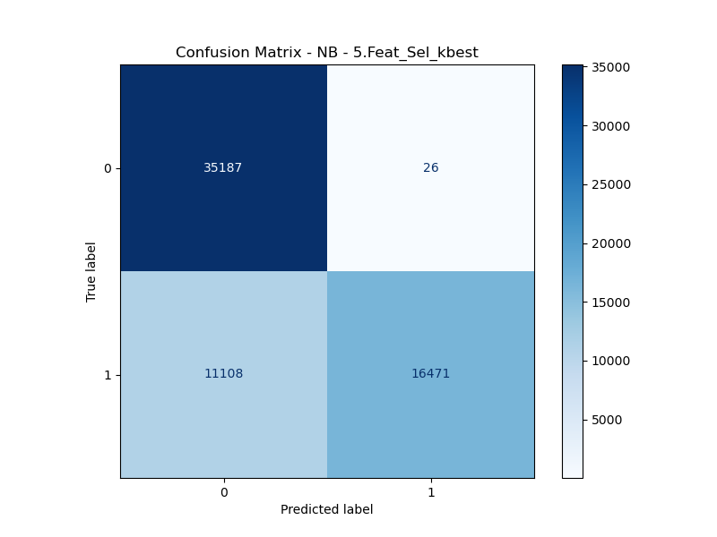

4. Conclusion
Through this iterative "Champion vs. Challenger" approach, we successfully optimized the data pipeline. This tailored approach ensured that every preprocessing decision was backed by empirical performance data rather than intuition alone.

